**A measurement campaign of air pollution freeways in Kuala Lumpur City: finding the sources, size distribution and the respiratory deposition**

Md Firoz Khan1, Mohd Talib latif2,3, Mazrura Sahani4, Khairul Nizam Maulud5, Abdul Basit Ahmad Tajudin4, Muhammad Ikram A Wahab4, Mohd Shahrul Mohd Nadzir1,2, Md Aynul Bari6, Yusri Yusuf7

1Centre for Tropical Climate Change System, Institute of Climate Change, Universiti Kebangsaan Malaysia, Bangi, Selangor, Malaysia

2School of Environmental and Natural Resource Sciences, Faculty of Science and Technology, Universiti Kebangsaan Malaysia, Bangi, Selangor, Malaysia

3Institute for Environment and Development (Lestari), Universiti Kebangsaan Malaysia, Bangi, Selangor, Malaysia

4Environmental Health and Industrial Safety Program, School of Diagnostic and Applied Health Sciences, Faculty of Health Sciences, Universiti Kebangsaan Malaysia, Jalan Raja Muda Abdul Aziz, Kuala Lumpur, **Malaysia**

5Earth Observation Centre, Institute of Climate Change, Universiti Kebangsaan Malaysia, 43600 Bangi, Selangor, Malaysia

6School of Public Health, University of Alberta, 3-57 South Academic Building, 11405-87 Avenue, Edmonton, Alberta, T6G 1C9, Canada

7School of Industrial Technology, Universiti Sains Malaysia, Penang, Malaysia

**Abstract**

Keywords: Urban air pollution; Street canyon; Emission from vegetation; Deposition to respiratory system

E-mail: [mdfiroz.khan@ukm.edu.my](mailto:mdfiroz.khan@ukm.edu.my); [mdfiroz.khan@gmail.com](mailto:mdfiroz.khan@gmail.com)

Centre for Tropical Climate Change System, Institute of Climate Change, Universiti Kebangsaan Malaysia, 43600 Bangi, Selangor, Malaysia

Tel.: +603-8911-8487; Fax: +603-8911-8490

**1 Introduction**

Short-Lived Climate Pollutants (SLCPs) such as tropospheric aerosols and ozone play a vital role to intensify global climate change. SLCPs also contribute to poor air quality by increasing indirectly the concentration of particulate matter (PM) and surface ozone. Atmospheric aerosols influence climate change by scattering and absorbing radiation, affect the formation of cloud droplets, and decrease visibility.

Atmospheric particles have potential detrimental effects on human health. Many studies on the health risks of atmospheric aerosols have established an implicit link between exposure to aerosols and increased rate of mortality and morbidity. The estimated costs due to the inhalation of particulate matter in Seoul are to be around $1057 million USD per year for acute exposure and $8972 million USD per year for chronic exposure. Air pollution due to the high concentration of SLCPs and ultrafine aerosol particles might render the severe exposure level at the street levels. The World Health Organization (WHO) recently published a report showing that there was the death of approximately 3.7 million people worldwide in 2012 due to the outdoor urban and rural sources of air pollution. It also showed that in the western Pacific and SEA alone, the reported number of deaths due to emissions from heavy industry was cited at about 2.6 million, and thus, SEA region experienced the largest count of air pollution hotspots in 2012 (WHO, 2014). A study brought the issue related to health of the urban people step ahead and discuss the findings of a study on the effect of microscopic air pollutants to the people living near freeways and power plants. The report discloses that the pollutants might make their ways to brain and damages it directly or they might attack it from a distance by triggering the release of inflammatory molecules (Underwood, 2017). A health study on the 500 million residents of Northern China showed that long-term exposure to an additional 100 μg/m3 of TSPs is associated with a reduction in life expectancy at birth of about 3.0 years (Chen et al., 2013).   
Thus, the architectures, sound infrastructures and a strong workforce of a city in planning has got less importance rather the healthy, sustainable and protecting vulnerable people are the common foundation to a modern city as described by WHO (2016). However, limited or no studies causes a huge knowledge gap at the current location. Therefore, the main focus of this research to evaluate the level of air particles with a wide range from 0.3 to 10 µm. The particle counts, mass concentration, volume weighted number and mass distribution were also being the ways to consider the strength of pollution near a freeway in the Kuala Lumpur City.

**2 Methodology**

*2.1 Description of the sampling site*

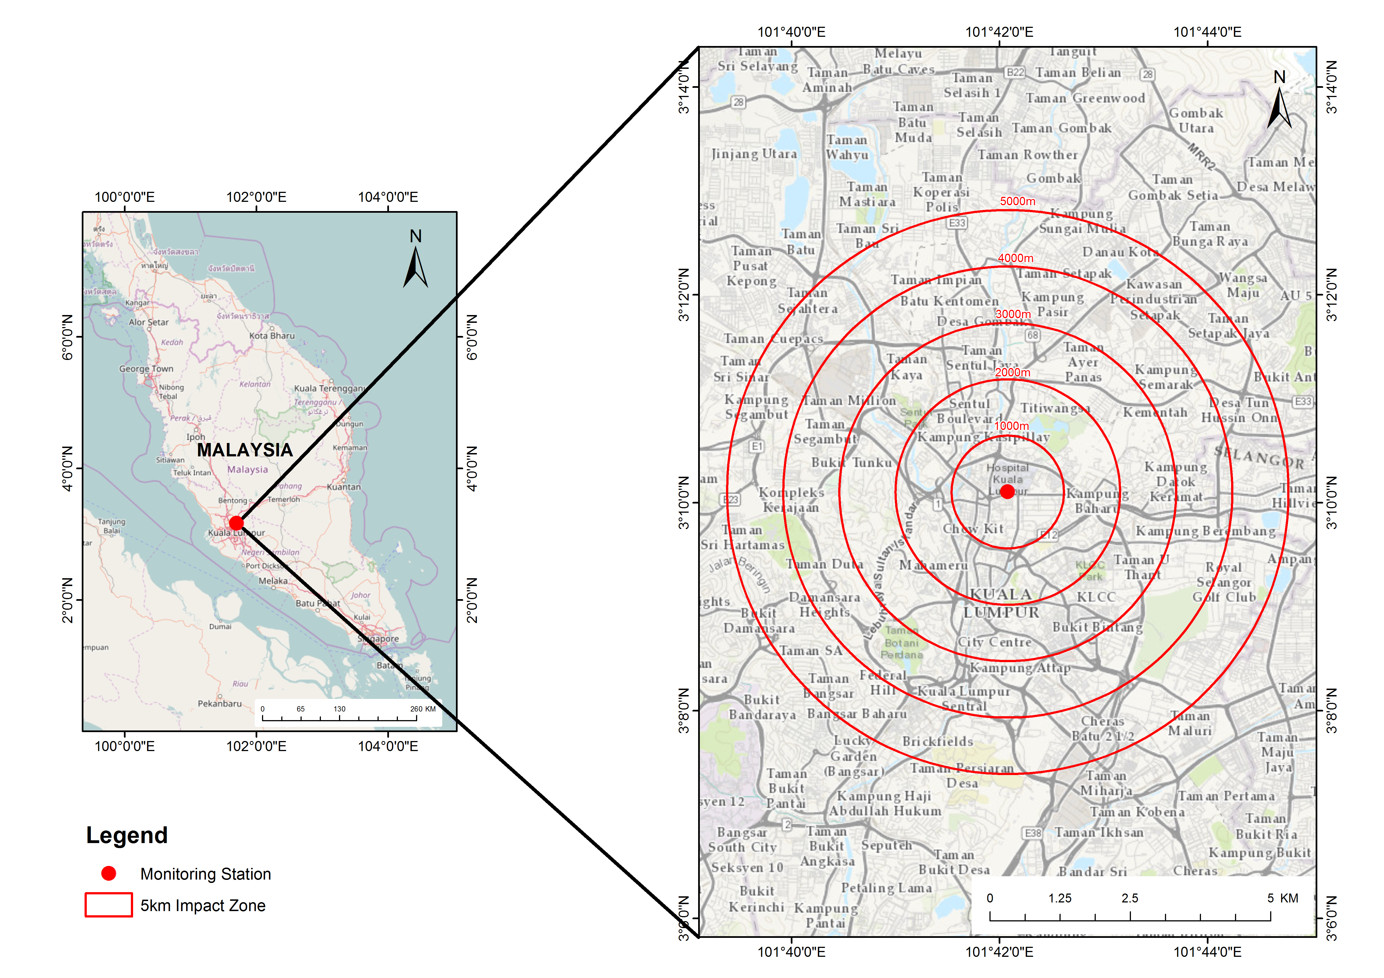

Figure 1 The sampling location near a freeway in Kuala Lumpur City

Figure 1 shows the sampling site located in a rooftop of a 3-storeyed building at the National University of Malaysia Kuala Lumpur campus (UKM KL). This building faces a busy city road network. According to the Malaysia Department of Transport, the total number of traffic with various modes travels**********in the morning, midday, afternoon and the evening, respectively. Further to the heavy frequency of traffic, there are several anthropogenic activities such as small scale combustion activities, industrial process, fuel stations, and construction dust as well as natural sources e.g. re-suspended road or soil dust. The above reported sources are located in the vicinity of 5 km radius from the sampling point.

*2.2 Measurement of the airborne particles*

A wide range of airborne particles was measured continuously using an Optical Particle Sizer Spectrometer (OPS) (Model 3330, TSI, USA). This instrument operates on the principle of single particle counting and can provide the accurate count size distribution for the particles with the optical diameter from the 0.3 to 10 µm a high resolution of 1 min.  The OPS uses a laser and a detector to detect particles passing through a sensing volume illuminated by the laser. The flow rate being sampled in to the instrument is 1.0 L/min. Additionally, there is 1.0 L/min of sheath flow supplied from the exhaust of the pump. Hence, sheath flow is internally circulated from the pump. Sheath flow keeps the particles well focused across the laser light and also prevents the optics from getting contaminated. Particles pass through the beam and light scattered by the particles is picked up by an elliptical mirror and focused onto the photodetector. The efficiency of this instrument is set as 50% count of a certain optical size range. Particle pulses are counted individually and binned into the 16 channels (number of channels can be varied) based on their pulse heights. The maximum particle size that can be counted is 10 μm. Particles above 10 μm will be counted but not sized.

*2.3 respiratory deposition*

**3 Results and Discussion**

**4 Conclusion**

**Acknowledgement**

The authors would like to thank the Universiti Kebangsaan Malaysia for Research University Grant GGPM-2016-034. The authors would also like to express the gratitude to Dr. Rose Norman (UK) for her assistance in proofreading this article.

**References**

Chen Y, Ebenstein A, Greenstone M, Li H. Evidence on the impact of sustained exposure to air pollution on life expectancy from China’s Huai River policy. Proceedings of the National Academy of Sciences 2013; 110: 12936-12941.

Underwood E. The polluted brain. Science 2017; 355: 342-345.

WHO. Ambient (outdoor) air quality and health. 2014.

WHO. Health as the Pulse of the New Urban Agenda. United Nations Conference on Housing and Sustainable Urban Development. Quito – October 2016. 2016.